HIGH LEVEL DOCUMENT
Spam Ham Classifier

Written by | Namrata Mishra
Last Revised Date | 19-January-2022

Contents:

1.Introduction

2.General Description

3.Design Details

4.Conclusion

1.Introduction

What is HLD?

(HLD) is the overall system design - covering the system architecture and database design. It describes the relation between various modules and functions of the system. Data flow, flow charts and data structures are covered under HLD.

2.General Description

Product Perspective

Spam Ham Classifier is a Machine Learning Model Using NLP(Count Vectorizer) and Naive Bayes Classifier.It is a binary classification .It is used to detect whether the message is a spam message or not.

Problem Statement

In recent times, unwanted commercial bulk emails called spam has become a huge problem on the internet. Spam prevents the user from making full and good use of time, storage capacity and network bandwidth. The huge volume of spam mails flowing through the computer networks have destructive effects on the memory space of email servers, communication bandwidth, CPU power and user time.Therefore,to prevent this spam-ham model is introduced.

Data Requirements

Data requirements depends upon the problem statement.

• A collection of 425 SMS spam messages was manually extracted from the Grumbletext Web site.

• A subset of 3,375 SMS randomly chosen ham messages of the NUS SMS Corpus (NSC), which is a dataset of about 10,000 legitimate messages collected for research at the Department of Computer Science at the National University of Singapore.

• A list of 450 SMS ham messages collected from Caroline Tag's PhD Thesis.

Tools Used

Python programming language such as pandas, scikit-learn are used to build the model.

*Jupyter Notebook and spyder is used as IDE.

*Heroku is used for the deployment of model.

*Front-end is done using html and css.

*Flask is used for API.

*Github is used as version control system.

3.Design Details

Proposed Methodology

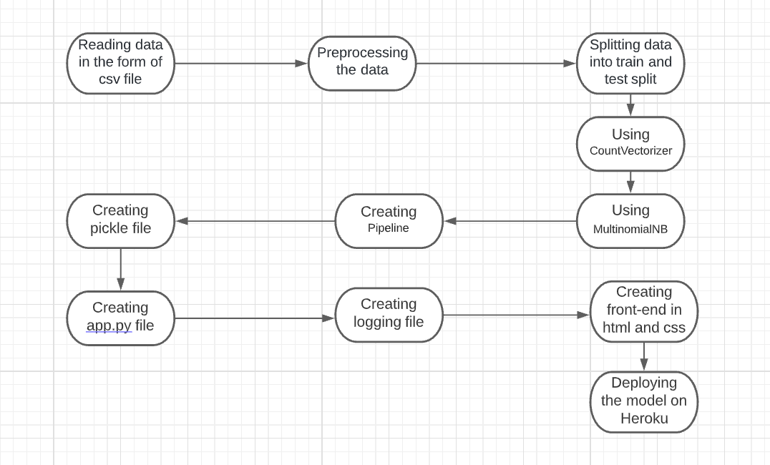

4.Conclusion
In terms of number of spam emails sent daily and the number of money people lose everyday because of these spam scams,spam filtering becomes the primary need of all email providing companies.

